RECEIVING
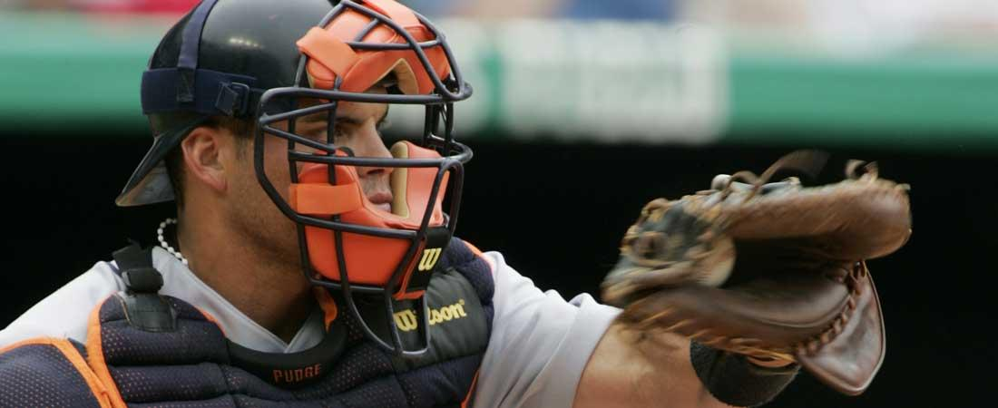
Receiving is a skill that can be developed if worked on properly. It's important to educate your catchers that receiving is a skill essential to their game. The better a catcher receives pitches, the more value he brings to a team.

KEEP YOUR EYES ON THE BALL
- A good receiver always follows the ball into the glove with his eyes.

ALWAYS GIVE A GOOD TARGET
- Proper positioning of the glove makes receiving easier. Remember to keep "fingers to the sky!"

BEAT THE BALL TO THE SPOT
- Anticipating where the ball is going to be when it crosses the plate and getting the glove to that spot before the ball gets there allows for a strong handle of the pitch. Failure to get the glove in position will let the velocity of the pitch dominate the glove. Catchers should not let the force of the pitch carry their glove out of the strike zone.
- Catching the outside parts of the ball for inside and outside pitches, top of the ball for high pitches and bottom of the ball for low pitches will put catchers in position to receive them correctly.

BE SOFT AND FIRM WHEN RECEIVING PITCHES
- It is necessary to have some softness and some firmness to receive correctly and efficiently.
- Catchers should be firm and "stick" pitches to present them to the umpire.
- Catchers should also be soft enough not to jab at the ball and drop the pitch.

CATCH THE BALL OUT IN FRONT OF THE BODY
- Give the umpire a good look at the pitch.
- More strikes are likely to be called the closer a catcher catches the ball to the plate.

CATCH STRIKES
- Catch all the strikes that are in the zone. Let them be strikes.

CATCH THE BORDERLINE PITCHES CORRECTLY
- Pitches that are borderline balls or strikes are the ones that catchers can affect the most.
- The catcher should keep his fingers to the sky and move his glove side-to-side in handling inside and outside borderline pitches.
- The catcher should avoid pointing his thumb to the ground when receiving pitches.
- Shifting body weight a little adds to the perception that a borderline pitch is a strike.

LET THE OBVIOUS BALLS BE BALLS
- A catcher should never try to make an obvious ball look like a strike. That will only irritate the umpire and is an unnecessary action.

A GOOD CATCHER GOES UNNOTICED
- One of the biggest compliments for a good receiving catcher is that he is unnoticeable. Limiting glove and body movement and catching the ball cleanly makes for a very good receiving catcher.
- Do not be in a hurry to jump out of the catching position on strike three.

