LEADERSHIP IN CATCHING
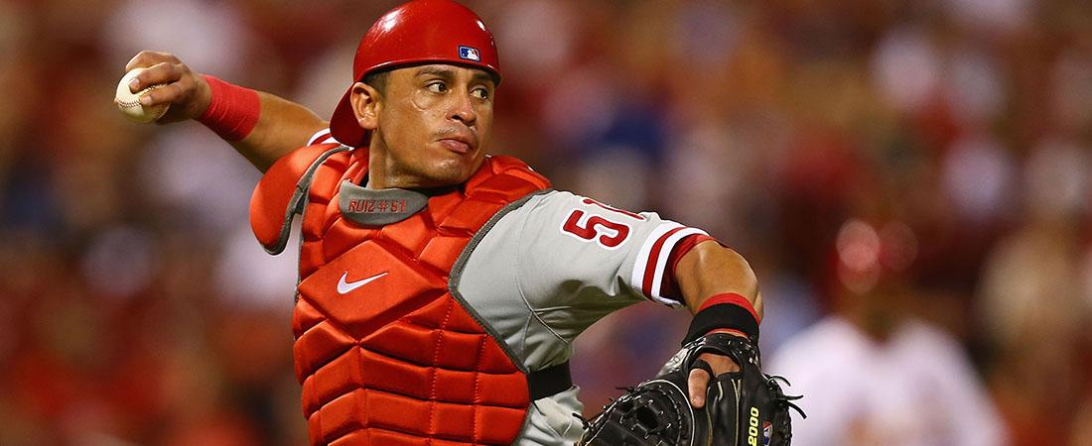
While leadership amongst all players is a great attribute, it's never more important than at the catching position. Regardless of talent level, there are basic ways in which a catcher can have a very positive impact on the team. Here are a few:

LEADERSHIP
- The catcher generally runs the game as the team's "quarterback."
- Confidence and hustle go a long way in setting a style in which a team plays.
- Every player on the field can see the catcher. The catcher should utilize this opportunity to lead by example. A confident demeanor influences a team positively.

COMMUNICATION
- The catcher must know all the strengths and weaknesses of the entire pitching staff. Therefore, communicating with the pitching staff becomes paramount in establishing trust in each other.
- The catcher must know the following about all of the pitchers on his team:
  - What is the pitcher's best pitch?
  - What kind of command do they have with each pitch?
  - How does their temperament affect their pitching?
  - How fast do they work?
  - Do they like mound visits?
  - Do they like to talk between innings?
- The catcher must be an extension of the manager on the field. Communicating with the manager and pitching coach about pitch strategies and/or game situations is vital.

CONTROL THE TEMPO OF THE GAME
- Establishing and maintaining a quality game tempo is largely the catcher's job. When the team is ahead, a quick tempo maintains momentum. Conversely, when the pitcher is struggling, the catcher can slow the game down to help the pitcher regain his composure and minimize the opponent's momentum.

CALLING A GAME
- Have a plan and help lead the pitcher in executing that plan.
- In general, stick with a pitcher's strength over a hitter's weakness.
- Don't be afraid to double up.
- Have a reason for every pitch called.
- Take pride in calling a winning game.

RESPONSIBILITY
- Lead by example.
- Control the tempo of the game.
- Control the running game.
- Work harder than anyone else on the field.
- Know the pitching staff's strengths and weaknesses.
- Never carry the burdens of at-bats to the defensive side of the game.
- Remind the pitcher to cover first base.
- Give all first and third defenses to the rest of the team's fielders.
- Communicate where to throw the ball on bunt plays.
- Be a vocal reminder to infielders on pop ups.
- Remind the infielders to throw to first base on 3-2 count and 2 out situations.
- Enjoy the demands of the position. Great demands produce great satisfaction.

